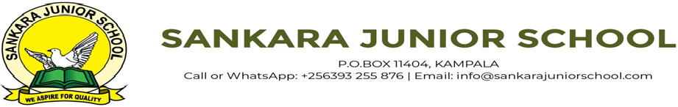

**END OF TERM ONE EXAMINATIONS 2023**

**MIDDLE CLASS**

**SOCIAL DEVELOPMENT**

NAME_______________________________

1. 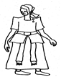**Match pictures to words**.

brother



father

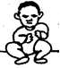

mother

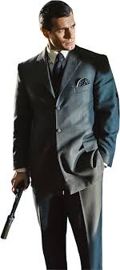

sister

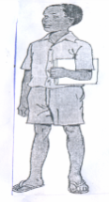

baby

1. **Read and draw**.

|  |  |  |
| --- | --- | --- |
| brother | father | mother |
|  |  |  |
| sister | baby |  |
|  |  |

1. Circle the correct word for the picture.

|  |  |  |
| --- | --- | --- |
|  | broom | cup |
| C:\Users\Secretary\Documents\OTHERS\new images\tools\Broom.png | plate | broom |
| C:\Users\secretary\Documents\OTHERS\new images\utencils\plate.png | plate | broom |
| C:\Users\Secretary\Documents\OTHERS\new images\Others\Mat.png | chair | mat |
|  | chair | mat |

1. Read and draw.

|  |  |  |
| --- | --- | --- |
| cup | broom | plate |
|  |  |  |
| chair | mat |  |
|  |  |  |

1. Match the same and draw.

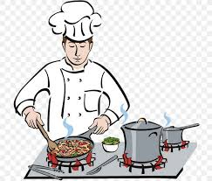

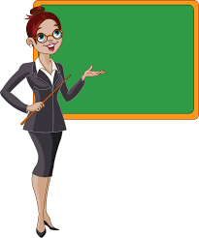

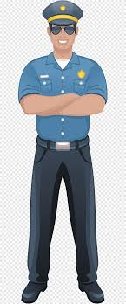

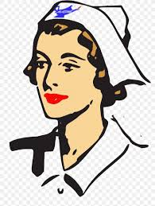









1. Oral questions.
2. What is your name?
3. What is the name of your headmaster?
4. How many days make a week?
5. In which class are you?
6. How old are you?